**The Gruve**

**Web Development Project Documentation**

***Presented by OBAJE JOSHUA ENEMAKU***

***Six-Month Diploma in Web Development***

***NIIT ABUJA***

**Date of Submission: 5th December, 2023**



***Year Founded:* 2012**

***Registered Nigeria Business:* Yes**

***Business Registration (CAC) Number:* 2324501**

***Contact Information:***

**Beside First Bank, Opposite Inikpi Hostel, Kogi State University, Anyigba, Kogi State**

**Phone: 0816 651 7978**

***Course Instructor: Mr. Fredrick***

**NIIT Abuja**

***Web Development Course***

***Document Version: 1.0***

***Acknowledgments:***

I express my sincere gratitude God first and to all those who have contributed to the development of "The Gruve" web project. Your support and guidance have been instrumental in shaping this innovative endeavor.

***Disclaimer:***

This document is a comprehensive overview of the web development project undertaken as part of the Six-Month Diploma in Web Development. The information presented is accurate to the best of our knowledge and is intended for academic purposes.

**INTRODUCTION**

"The Gruve" is not just a restaurant; it's a modern relaxation hub that revolves around a central, classy eatery at the heart of its operations. Founded in 2012, we embarked on a journey with a visionary goal - to revolutionize the restaurant industry and provide an unparalleled experience for our patrons.

**Brief Overview of "The Gruve" Website**

At "The Gruve," our online presence is an extension of our commitment to delivering excellence in the culinary and hospitality domain. The website serves as a digital gateway for our patrons, offering a seamless and user-friendly experience. Visitors can explore our diverse menu, place food orders, and even get a glimpse of the sophisticated ambiance that awaits them at our physical location.

**Purpose and Objectives of the Project**

The primary purpose of "The Gruve" website is to enhance customer engagement and streamline the process of ordering food. We understand the evolving needs of our clientele and recognize the importance of providing a digital platform that complements our physical establishment. The website is designed to be an extension of the exceptional service and atmosphere that patrons experience when they visit our classy eatery.

**Objectives:**

Efficient Ordering: Simplify the food ordering process, allowing customers to browse the menu, customize their orders, and place them effortlessly.

Enhanced Customer Experience: Extend the unique ambiance of our physical location to the digital realm, creating a cohesive brand experience.

Accessibility: Ensure that our services are accessible to a wider audience, making it convenient for both local and distant customers to enjoy "The Gruve" experience.

Information Dissemination: Provide up-to-date information about our location, operating hours, and any special events or promotions.

The project aims to bridge the gap between the traditional dine-in experience and the digital era, offering our patrons a comprehensive and convenient way to engage with "The Gruve" at their own pace and preference. We are excited about the possibilities this project brings and look forward to continuously elevating the standards of the restaurant industry.

**Brief Overview of the Project**

"The Gruve" website is a pivotal component of our commitment to innovation and customer satisfaction. This online platform seamlessly integrates with our physical establishment, offering a comprehensive solution for patrons to engage with our brand. From exploring our diverse menu to placing orders for their favorite dishes, the website serves as a virtual extension of the exceptional services provided at our central classy eatery.

The website incorporates modern design principles, ensuring a visually appealing and user-friendly interface. It is not merely a transactional tool but a dynamic portal that mirrors the sophistication and ambiance associated with "The Gruve" brand. Through intuitive navigation and interactive features, users can immerse themselves in the culinary journey that awaits them at our physical location.

**Importance and Relevance**

In an era where digital interactions have become integral to daily life, having a robust online presence is paramount for any business. For "The Gruve," the website is not just a supplement; it's a strategic asset that enhances customer engagement and convenience. Its importance and relevance are underscored by several key factors:

1. **Accessibility:** The website extends our reach beyond the confines of our physical location. Anyone, from local residents to distant patrons, can access our menu, place orders, and gather information at their convenience.
2. **Customer Empowerment:** By providing a user-friendly platform, we empower our customers to tailor their dining experience. From exploring the menu to customizing orders, patrons have greater control over their interactions with "The Gruve."
3. **Brand Cohesion:** The website ensures a consistent brand experience. The digital platform mirrors the ambiance and style of our central eatery, fostering brand cohesion and recognition.
4. **Streamlined Operations:** The online ordering system streamlines our operational processes. It reduces order processing time, minimizes errors, and enhances overall efficiency in delivering our services.
5. **Innovation in the Industry:** "The Gruve" sets a precedent by embracing technological innovation in the restaurant industry. The website positions us as forward-thinking, adapting to the evolving needs and preferences of our clientele.

The introduction of "The Gruve" website is not just a response to the digital age; it's a strategic move to enhance customer experience, streamline operations, and set new standards in the restaurant industry. It embodies our commitment to excellence and our unwavering vision of revolutionizing the way patrons interact with and enjoy their dining experiences.

**PROJECT OBJECTIVES**

***a. What the Website Aims to Achieve***

"The Gruve" website is strategically designed with the following objectives in mind, each contributing to the overall enhancement of our patrons' experience and the operational efficiency of our establishment:

1. **Seamless Ordering Experience:** The primary goal of the website is to provide patrons with a seamless and intuitive platform for placing food orders. Through a user-friendly interface, customers can effortlessly navigate our menu, customize their orders, and complete transactions with ease.
2. **Digital Ambiance Extension:** We aim to extend the sophisticated ambiance of our central classy eatery into the digital space. The website incorporates visual elements and design principles that reflect the unique atmosphere patrons experience when dining in at "The Gruve."
3. **Information Accessibility:** The website serves as a comprehensive source of information for our patrons. From our location near First Bank, opposite Inikpi Hostel, Kogi State University, Anyigba, to contact details, operating hours, and special events, we strive to keep our audience well-informed.
4. **Inclusivity and Accessibility:** By providing an online ordering system, we aim to make our services accessible to a broader audience. Whether patrons are local residents or located at a distance, they can engage with "The Gruve" conveniently through the website.

***b. Target Audience***

"The Gruve" caters to a diverse audience, embracing the idea that everyone deserves a refined and enjoyable dining experience. Our target audience includes:

**i. Local Residents:** Individuals residing in the vicinity of Anyigba, particularly students and professionals, who seek a high-quality dining experience.

**ii. University Community:** With our proximity to Kofi State University, we target students, faculty, and staff who are looking for a sophisticated yet comfortable place to dine.

**iii. Digital Natives:** Embracing the digital era, we target individuals who prefer the convenience of online interactions. The website caters to tech-savvy customers who appreciate the ease of browsing menus and placing orders from their devices.

**iv. Food Enthusiasts:** Beyond the local community, "The Gruve" aims to attract food enthusiasts who are willing to explore and indulge in a diverse and well-crafted menu.

In essence, the website serves as a bridge, connecting our central classy eatery with a broader audience, ensuring that everyone, regardless of their location or technological preferences, can partake in the exceptional culinary experience offered by "The Gruve."

**TECHNOLOGIES USED**

***a. Highlight Key Technologies***

"The Gruve" website leverages a combination of frontend technologies to ensure a visually appealing, interactive, and user-friendly experience. Although the backend is still under development, the frontend technologies play a crucial role in laying the foundation for an efficient and engaging web application.

**i. HTML (HyperText Markup Language):**

* Foundation for structuring the website.
* Ensures semantic and organized content presentation.
* Supports the integration of other technologies and frameworks.

**ii. CSS (Cascading Style Sheets):**

* Responsible for styling and layout.
* Enhances the visual appeal of the website.
* Ensures a responsive design for various screen sizes and devices.

**iii. JavaScript:**

* Provides dynamic and interactive features on the client side.
* Enables real-time updates and user interactions.
* Enhances the overall user experience.

**iv. Ajax (Asynchronous JavaScript and XML):**

* Facilitates asynchronous data exchange with the server.
* Allows for seamless, real-time updates without requiring a page refresh.
* Enhances the website's responsiveness and user interactivity.

**v. CDN Libraries:**

* **Font Awesome Icons:**
  + Utilized for incorporating scalable vector icons that enhance visual elements.
  + Adds a modern and professional touch to the website's aesthetics.
* **Notification Libraries (Sweet Alert and Toastr):**
  + **Sweet Alert:** Enhances user notifications with attractive, customizable pop-up alerts.
  + **Toastr:** Provides non-intrusive, easily customizable notifications for a smooth user experience.
  + Both libraries contribute to an improved user feedback system.

b. Visual Elements (Icons, Logos)

"The Gruve" understands the significance of visual elements in creating an appealing and memorable online presence. Visual elements contribute to brand recognition and enhance the overall aesthetics of the website.

**i. Icons:**

* **Font Awesome Icons:** These scalable vector icons are employed to add a touch of modernity and professionalism to the website. Icons are strategically used for navigation, improving user experience, and reinforcing brand identity.

**ii. Notification Libraries:**

* **Sweet Alert:** This library enhances the visual appeal of notifications, presenting them in an attractive and user-friendly manner. The use of Sweet Alert ensures that important messages are communicated effectively to the users.
* **Toastr:** The Toastr library provides sleek and non-intrusive notifications, ensuring that users are informed without disrupting their browsing experience. This contributes to a seamless and pleasant interaction with the website.

In the absence of a backend, these frontend technologies lay a robust foundation for the future integration of backend functionalities. The strategic use of visual elements ensures that "The Gruve" website not only functions seamlessly but also leaves a lasting and positive impression on its users.

**SYSTEM ARCHITECTURE**

***a. Diagram Illustrating the High-Level Architecture***

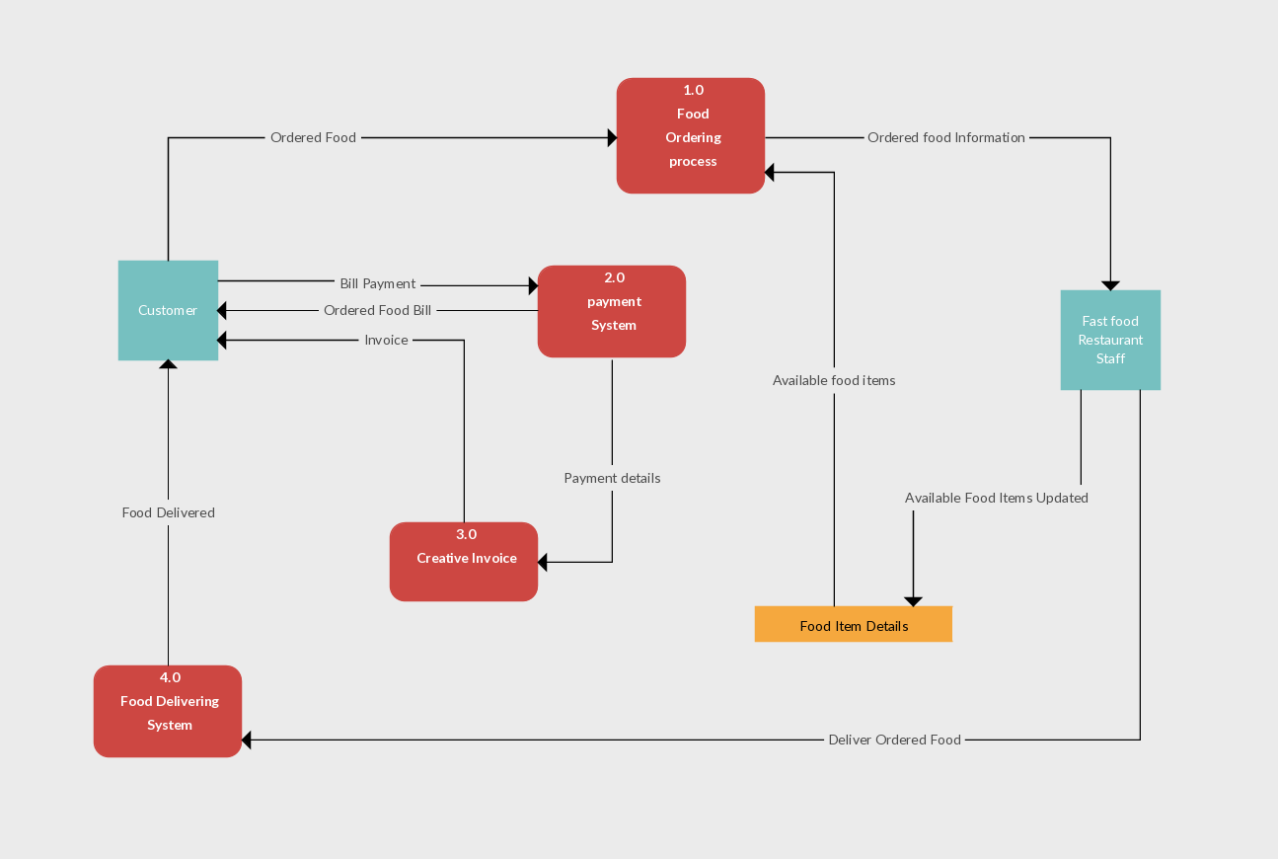

*High-Level Architecture Diagram on Food restaurant website*

**Brief Explanation of Components**

The system architecture of "The Gruve" website is designed to be modular, scalable, and focused on delivering a seamless user experience. While the backend is still in development, the current architecture primarily revolves around the frontend technologies and the integration of CDN libraries for enhanced functionality.

**i. Frontend Components:**

* **HTML, CSS, and JavaScript:** These form the core building blocks of the website, responsible for structuring content, styling elements, and providing dynamic interactions.
* **Ajax (Asynchronous JavaScript and XML):** Facilitates asynchronous communication with the server, enabling real-time updates without the need for page reloads. This enhances the responsiveness of the website.

**ii. CDN Libraries:**

* **Font Awesome Icons:** Integrated for the incorporation of scalable vector icons, enhancing the visual appeal and professionalism of the website.
* **Notification Libraries (Sweet Alert and Toastr):**
  + **Sweet Alert:** Used for customizable and visually appealing pop-up alerts, improving the presentation of important messages.
  + **Toastr:** Implemented for non-intrusive, customizable notifications, ensuring a smooth and user-friendly notification system.

**1. User Interface (UI):** The UI layer is built using HTML for structure, CSS for styling, and JavaScript for dynamic interactions. It ensures a visually appealing and responsive design, providing a seamless experience across various devices.

**2. Client-Side Logic:** JavaScript is responsible for client-side logic, handling user interactions and real-time updates. Ajax facilitates asynchronous communication with the server, allowing for dynamic content retrieval without reloading the entire page.

**3. Notification System:** Sweet Alert and Toastr libraries enhance the notification system. Sweet Alert provides attractive pop-up alerts for critical messages, while Toastr delivers non-intrusive notifications, ensuring users are informed without disruption.

**4. Scalable Icons:** Font Awesome Icons are utilized throughout the website to add modern and scalable vector icons, contributing to a polished and professional appearance.

**5. Future Backend Integration:** While the backend is currently under development, the frontend architecture is designed to seamlessly integrate with backend functionalities. This includes order processing, user authentication, and data management, enhancing the overall capabilities of the website.

This high-level architecture prioritizes user experience, responsiveness, and scalability. As the backend components are integrated in the future, this architecture will evolve to accommodate more robust features, ensuring "The Gruve" continues to deliver a revolutionary and delightful experience for its users.

Top of Form

**DESIGN AND UI**

**Wireframes:** Wireframes serve as the blueprint for the website, outlining the structural layout and basic functionality. Here are some key components:

* *Homepage:* A clean and inviting layout with sections for featured dishes, promotions, and easy navigation to the menu.

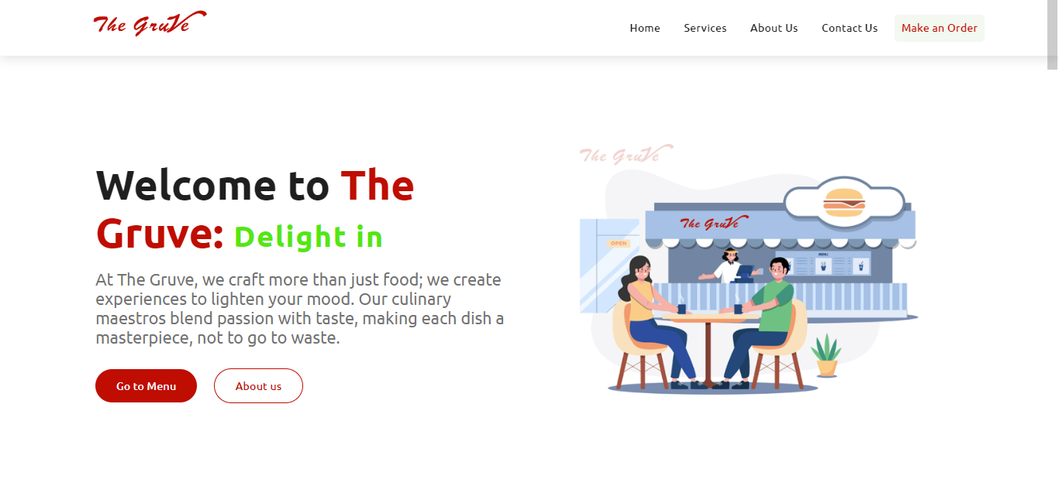

* *Menu Page:* Intuitive categorization of dishes with high-quality images, detailed descriptions, and prices.

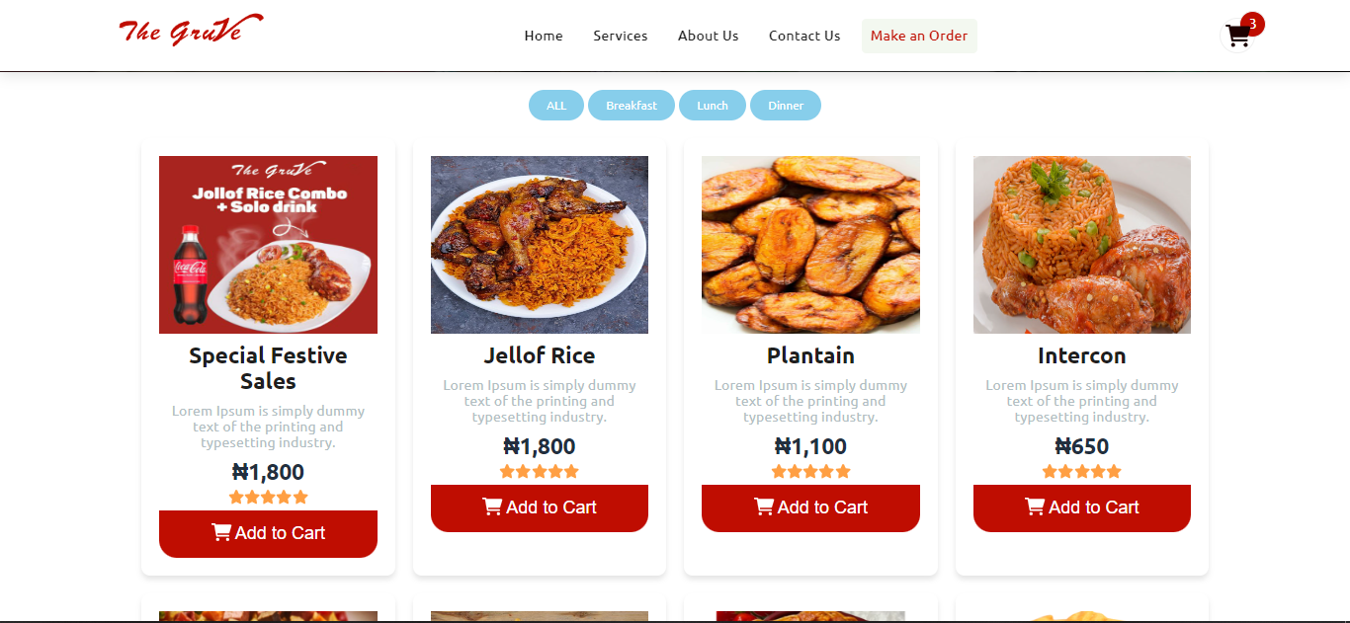

* *Ordering Process:* A streamlined and user-friendly interface for customizing orders, adding items to the cart, and proceeding to checkout.
* *Contact & About Information:* Clear display of "The Gruve" location, contact details, and operational hours.

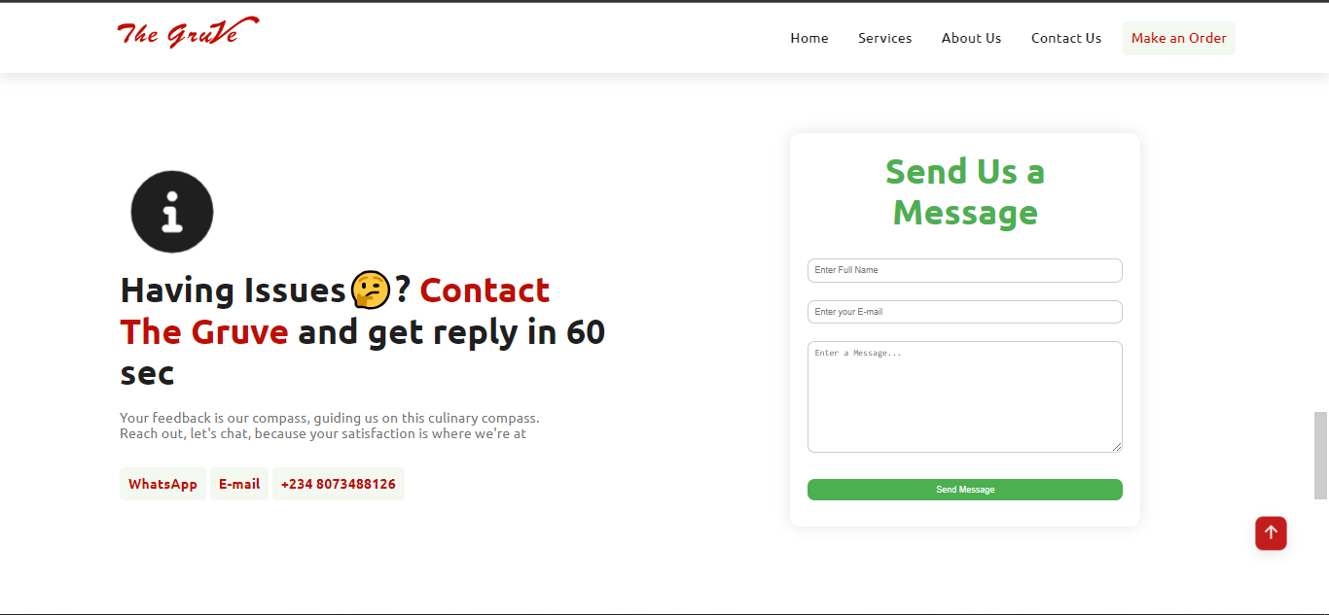

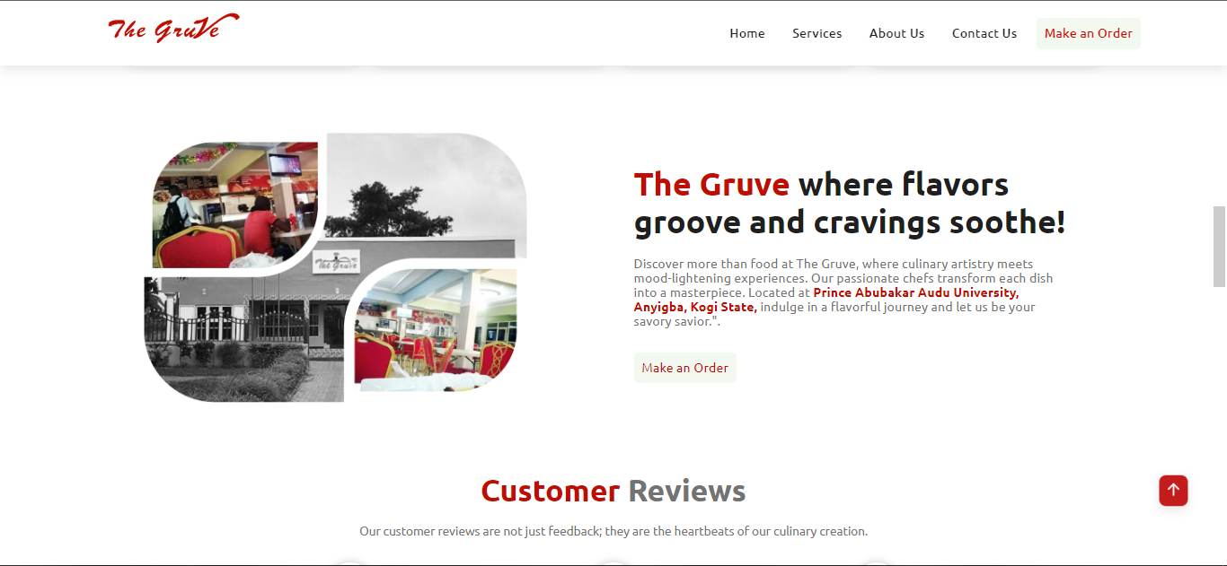

**Mockups:** Mockups provide a more detailed and visually realistic representation of the website design. These include:

* *Homepage:* Visual elements like high-resolution images of signature dishes, an interactive slider, and strategically placed call-to-action buttons.
* *Menu Page:* A visually appealing presentation of dishes with images, nutritional information, and filters for dietary preferences.
* *Ordering Process:* Step-by-step visuals of the ordering process, showcasing the simplicity of selecting items, customizing options, and confirming orders.
* *Contact Information:* Visual representation of the location on a map, contact form, and links to social media profiles.

**Color Scheme:** "The Gruve" adopts a sophisticated and appetizing color scheme to evoke a sense of warmth and class. The primary colors include:

* *Deep Burgundy:* Symbolizing richness and elegance, this color is used in the background and accents.
* *Creamy Beige:* Applied to text and other elements, providing a contrast that enhances readability.
* *Golden Yellow:* Highlight color used sparingly for call-to-action buttons and special offers, adding vibrancy.

**Branding:** "The Gruve" branding is a blend of modernity and sophistication:

* **Logo:** A sleek logo featuring a stylized plate with utensils, representing a commitment to culinary excellence. The logo incorporates the chosen color palette for brand consistency.



* **Typography:** Clean and modern fonts are used for headings and body text, ensuring readability and aligning with the overall brand aesthetic.
* **Imagery:** High-quality images of signature dishes and the restaurant's ambiance contribute to a visual narrative that resonates with the brand.

The combination of wireframes, mockups, color scheme, and branding elements ensures a visually cohesive and inviting online presence for "The Gruve." This meticulous design approach aims to enhance user engagement and convey the essence of the restaurant's ambiance through the digital platform.

**FEATURES**

*a. Highlight Key Features with Visuals*

**1. Interactive Menu:**

* **Visual Element:** Screenshots of the menu page showcasing appetizing images of dishes.
* **Feature Highlights:** Users can easily navigate through categories, view dish details, and make selections.

**2. Seamless Ordering Process:**

* **Visual Element:** Step-by-step screenshots of the ordering process.
* **Feature Highlights:** Intuitive interface for customizing orders, adding items to the cart, and smooth checkout.

**3. Real-Time Updates:**

* **Visual Element:** Screenshots or animations demonstrating real-time updates.
* **Feature Highlights:** Users receive instant feedback on order status and any changes made during the ordering process.

**5. Responsive Design:**

* **Visual Element:** Side-by-side visuals of the website on various devices.
* **Feature Highlights:** Ensures a consistent and engaging experience across desktops, tablets, and smartphones.

**6. Notification System:**

* **Visual Element:** Screenshots showcasing Sweet Alert and Toastr notifications.
* **Feature Highlights:** Visual and non-intrusive notifications for order confirmations, promotions, and alerts.

**7. Contact and Location Information:**

* **Visual Element:** Map integration and screenshots of contact details.
* **Feature Highlights:** Easy access to the restaurant's location, contact information, and operational hours.

b. Brief Demonstrations (Screenshots or Animations)

**Interactive Menu:**

* *Screenshot 1:* Displaying the menu interface with categories and featured dishes.
* *Animation:* Navigating through menu categories and making selections.



**Seamless Ordering Process:**

* *Screenshot 1:* Adding items to the cart with quantity and customization options.
* *Animation:* Smooth transition through each step of the ordering process.

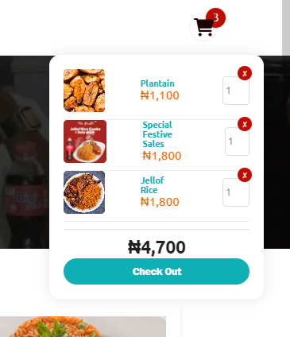

**Responsive Design:**

* *Screenshot 1:* Website on a desktop screen.
* *Screenshot 2:* Website on a tablet.
* *Screenshot 3:* Website on a smartphone.
* *Animation:* Responsive transitions between different devices.



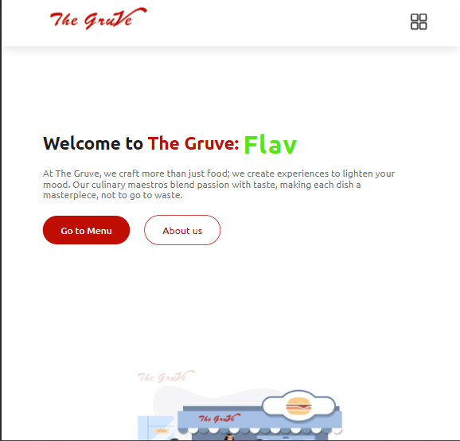

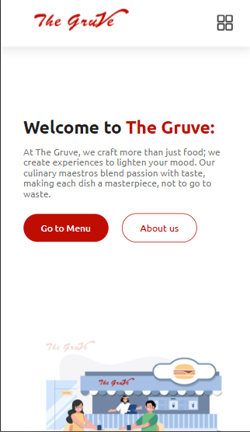

**Notification System:**

* *Screenshot 1:* Sweet Alert notification for Checkout confirmation.



* *Screenshot 2:* Toastr notification for Error and success signals.



* *Animation:* Simulated user interactions triggering notifications.

**Contact and Location Information:**

* *Screenshot 1:* Contact details and social media links.



These visual demonstrations provide a glimpse into the user experience, showcasing the key features and functionalities of "The Gruve" website. Users can see the seamless flow from exploring the menu to placing an order and receiving real-time updates, ensuring a delightful and efficient online dining experience.

**CHALLENGES AND SOLUTIONS**

*a. Issues Encountered During Development*

In the course of developing "The Gruve" website, several challenges were identified, with a primary focus on local storage and additional considerations:

**1. Local Storage Limitations:**

* **Issue:** Local storage, a crucial component for maintaining user data on the client side, has limitations, especially in terms of storage capacity.
* **Impact:** The storage limitations may affect the website's ability to save and retrieve extensive user data, potentially hindering features like order history and personalized preferences.

**2. Security Concerns with Local Storage:**

* **Issue:** Storing sensitive user information, such as authentication tokens, in local storage raises security concerns.
* **Impact:** The vulnerability of local storage to cross-site scripting (XSS) attacks may compromise user data, leading to unauthorized access.

**3. Limited Backend Integration:**

* **Issue:** As the backend is still under development, certain features reliant on server-side functionalities remain inactive.
* **Impact:** Seamless user authentication, real-time order updates, and comprehensive data storage are affected until backend integration is complete.

*b. Solutions Implemented*

**1. Local Storage Optimization:**

* **Solution:** Implementing a strategy to optimize local storage usage, prioritizing essential data storage and clearing outdated or less critical information.
* **Outcome:** This approach ensures efficient use of local storage resources, mitigating issues related to capacity limitations.

**2. Enhanced Security Measures:**

* **Solution:** Utilizing secure practices such as encryption and token management to enhance the security of sensitive data stored in local storage.
* **Outcome:** Strengthening security measures reduces the risk of unauthorized access and fortifies the protection of user information.

**3. Temporary Data Management:**

* **Solution:** Implementing temporary data management practices to simulate backend functionalities, allowing for a smoother user experience even in the absence of a fully integrated backend.
* **Outcome:** Users can still enjoy essential features such as browsing the menu, customizing orders, and receiving simulated real-time updates until the backend is fully functional.

**FUTURE ENHANCEMENTS**

*a. Potential Features to Add*

As "The Gruve" progresses towards backend development and database integration, and considers future expansion into mobile applications, here are key enhancements to elevate the overall functionality and user experience:

**1. Comprehensive Backend Integration:**

* **Objective:** Achieve full integration of a robust backend, enabling user authentication, secure data storage, order processing, and real-time updates.
* **Impact:** The website will transition from simulated backend functionalities to a fully operational system, ensuring a seamless and secure user experience.

**2. User Account Customization:**

* **Objective:** Enable users to create accounts, customize profiles, and manage personal preferences.
* **Impact:** Users can save favorite orders, track order history, and experience a more personalized interaction with "The Gruve."

**3. Loyalty Programs and Discounts:**

* **Objective:** Introduce loyalty programs, discounts, and promotional features tied to user accounts.
* **Impact:** Encourages customer retention, repeat business, and a sense of appreciation for loyal patrons.

**4. Social Media Integration:**

* **Objective:** Integrate social media features, allowing users to share their dining experiences, leave reviews, and engage with the community.
* **Impact:** Expands brand reach, leverages user-generated content, and fosters a sense of community around "The Gruve."

**5. Mobile Applications:**

* **Objective:** Develop dedicated mobile applications for iOS and Android platforms.
* **Impact:** Provides users with a convenient, on-the-go experience, including features like push notifications, mobile ordering, and seamless access to promotions.

*b. Technologies to Explore for Future Development*

**1. Backend Technologies:**

* **Consideration:** Explore backend frameworks such as Django, Node.js selecting the one best suited to the project requirements.
* **Rationale:** A robust backend is critical for handling user authentication, data management, and ensuring a secure and scalable infrastructure.

**2. Database Integration:**

* **Consideration:** Implement a relational database management system (RDBMS) or NoSQL database based on the data structure and requirements.
* **Rationale:** Efficient database management is essential for storing and retrieving user information, order history, and other critical data.

**3. Mobile App Development Frameworks:**

* **Consideration:** Utilize frameworks like React Native or Flutter for cross-platform mobile app development.
* **Rationale:** Cross-platform frameworks streamline development, ensuring a consistent user experience on both iOS and Android devices.

**4. Progressive Web App (PWA) Enhancement:**

* **Consideration:** Continue optimizing the website as a Progressive Web App (PWA) for enhanced offline capabilities and improved performance.
* **Rationale:** PWAs offer a seamless transition between web and mobile experiences, catering to diverse user preferences.

**5. Cloud-Based Solutions:**

* **Consideration:** Leverage cloud-based solutions for backend infrastructure, ensuring scalability and reliability.
* **Rationale:** Cloud services enhance flexibility, facilitate seamless scaling, and provide robust security measures.

**CONCLUSION**

In conclusion, "The Gruve" website marks a significant step towards revolutionizing the restaurant industry. With a modern relaxation hub at its core, our central classy eatery sets the stage for an unparalleled dining experience. The website, though currently focusing on the frontend, lays a solid foundation with technologies such as HTML, CSS, JavaScript, Ajax, and CDN libraries. Notable features include an interactive menu, seamless ordering, real-time updates, and a strategic notification system.

We have addressed challenges associated with local storage, implementing optimizations and enhanced security measures. As we look towards future enhancements, the integration of a robust backend, user account customization, loyalty programs, and social media engagement stand as key objectives. The prospect of mobile applications further extends our commitment to providing a convenient and accessible dining experience.

We express our gratitude to everyone who has taken the time to engage with the development journey of "The Gruve" website. Your attention and interest are invaluable as we strive to create a digital platform that complements the sophistication and excellence of our physical establishment. We look forward to your continued support and feedback as we work towards delivering an exceptional and innovative dining experience.

At this point, we open the floor for any questions or inquiries you may have kindly send it to below mail box ***joshuaenemaku4@gmail.com***. Your feedback and queries are highly valuable as we continue to refine and enhance "The Gruve" website. Feel free to share your thoughts, and we'll be delighted to provide insights into our development process and future plans. Thank you for your attention, and we appreciate your active participation in this discussion.